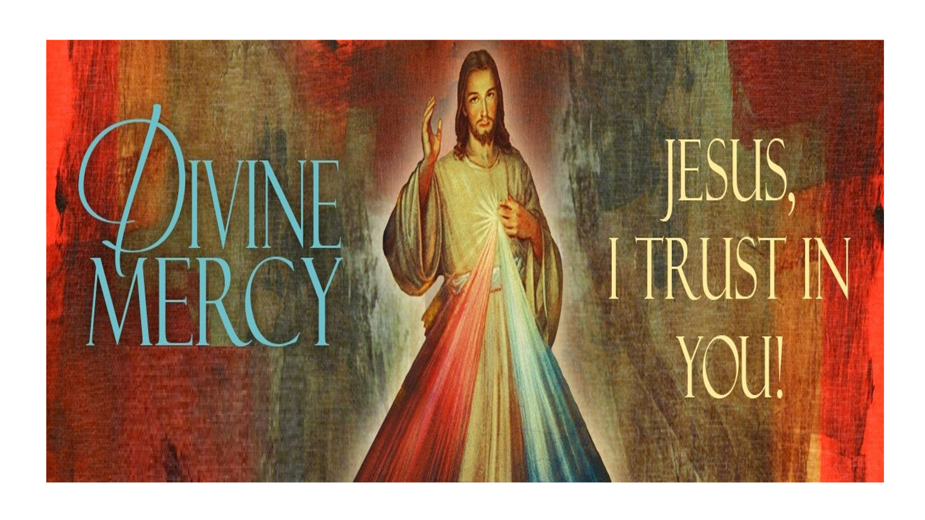

DIVINE MERCY SUNDAY HOLY HOUR
St. Michael the Archangel Parish
April 12 2026
3:00 PM
The Holy Hour will include exposition of the Blessed Sacrament, singing of the Divine Mercy Chaplet, Litany to the Divine Mercy, readings from the Diary of St. Faustina and Benediction/The Divine Praises.
Please, join Our Lord of Mercy on Divine Mercy Sunday.

